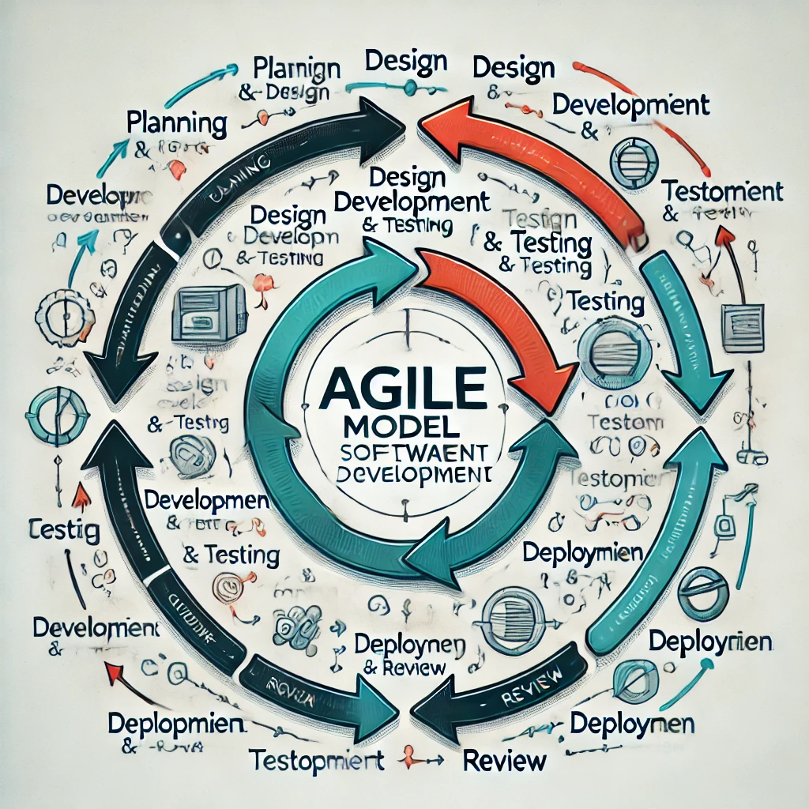

**Explanation of the First Image: Agile Model Diagram**

1. **Overall Structure**:
   * The diagram illustrates the Agile model in software development, characterized by an iterative and incremental approach.
   * The structure is circular or looped, representing the continuous cycle of development and feedback.
2. **Phases**:
   * **Planning**:
     + Initial phase where requirements are gathered, and the scope is defined.
   * **Design**:
     + The system's architecture and design are created based on the planning.
   * **Development**:
     + Actual coding and software development occur in this phase.
   * **Testing**:
     + Software is tested for bugs and to ensure it meets the requirements.
   * **Deployment**:
     + The software is deployed for use after successful testing.
   * **Review**:
     + Continuous feedback is gathered, leading to further planning and iteration.
3. **Flow**:
   * The arrows indicate a looped flow, emphasizing that the Agile process is continuous, with each phase leading to the next in a repetitive cycle.

**Explanation of the Second Image: Agile Model with Focus on QA Testing**

1. **Overall Structure**:
   * Similar to the first diagram, this image also depicts the Agile model but with a specific emphasis on Quality Assurance (QA) testing.
   * The structure remains circular, representing the iterative nature of Agile development.
2. **Phases**:
   * **Planning**:
     + Requirements and scope are gathered and defined.
   * **Design**:
     + The system's architecture and design are crafted.
   * **Development**:
     + Software is developed through coding.
   * **Testing (QA)**:
     + This phase is prominently featured to highlight the importance of continuous testing throughout the development cycle.
   * **Deployment**:
     + The software is deployed after testing.
   * **Review**:
     + Feedback is collected and used for further iterations.
3. **Focus on Testing (QA)**:
   * The **Testing (QA)** phase is visually highlighted, indicating its critical role in ensuring that the software meets quality standards at every iteration.
4. **Flow**:
   * The looped arrows signify the continuous, iterative nature of the Agile process, with testing being integral to each cycle.